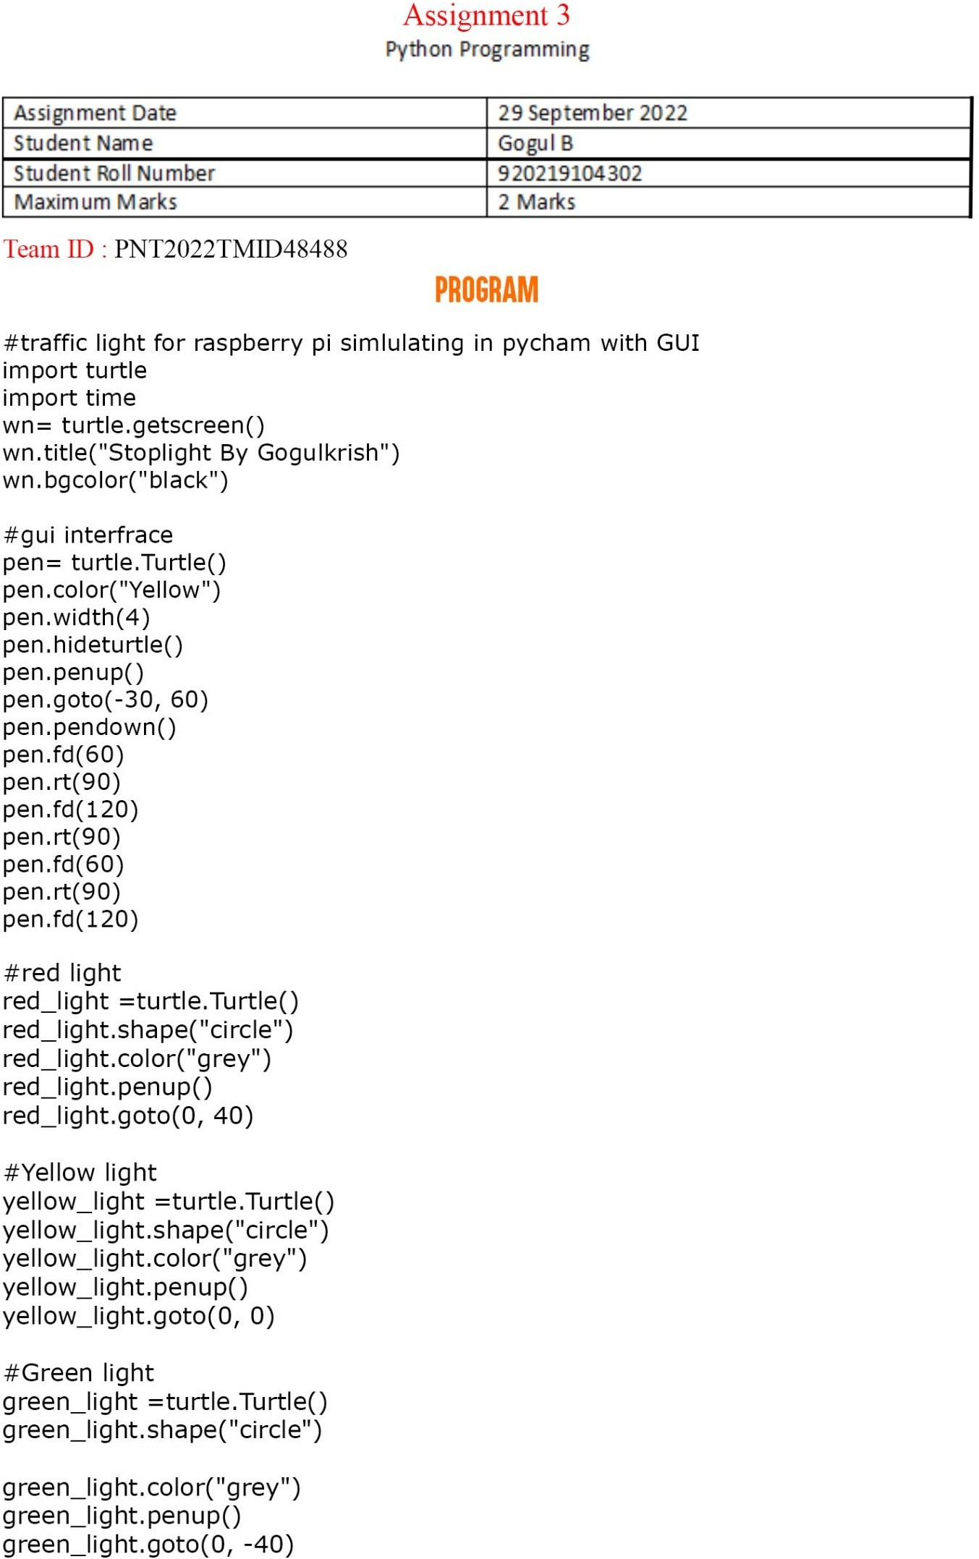

ASSIGNMENT --- 3 Python Programing

TEAM ID : PNT2022TMID03883

